**Publish the Power BI report**

## Step 1: Publish the dataset and report

1. In Power BI Desktop, on the **Home** tab, click or tap **Publish**.

Publish dataset and report.

1. If you're not already signed in to the Power BI service, enter an account, then click or tap **Sign in**.

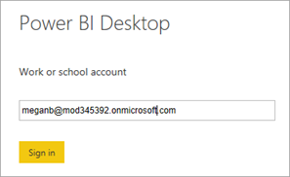

1. Enter a password, then click or tap **Sign in**.

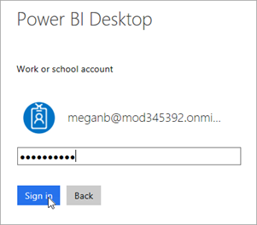

1. Choose a destination for the report, then click or tap **Select**. We recommend publishing to a group workspace to simplify access to the report in SharePoint. In this case, we are publishing to the **Project Management** group workspace. For more information, see [Collaborate in your Power BI app workspace](https://docs.microsoft.com/en-us/power-bi/service-collaborate-power-bi-workspace).

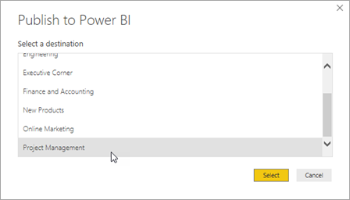

1. After publishing completes, click or tap **Open 'project-analysis.pbx' in Power BI**.

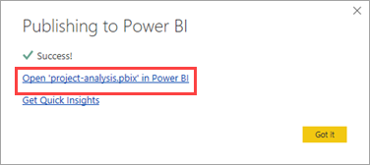

1. The Power BI service loads the report in a browser. If the left navigation pane isn't expanded, click or tap the menu at the top left **(a)** to expand it.

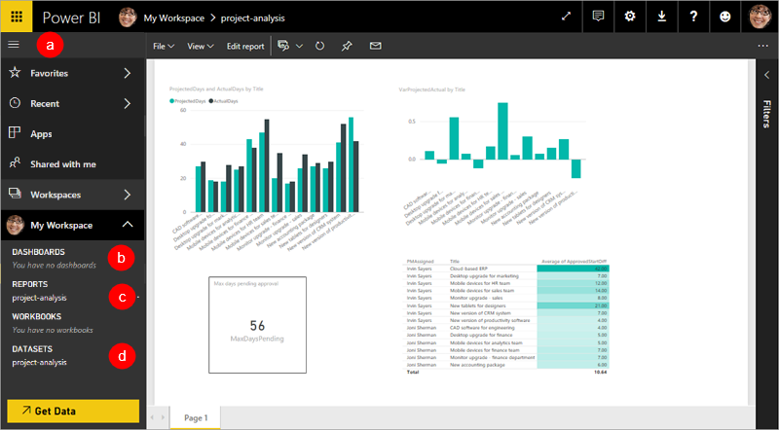

You can see that when we published, Power BI Desktop uploaded a dataset **(d)** and a report **(c)**. You create dashboards in the service, not Power BI Desktop, and this workspace doesn't have any dashboards yet **(b)**. We'll create one shortly.

## Step 2: Configure credentials for refresh

1. In the service, click or tap Gear icon. in the top right corner, then click or tap **Settings**.
2. Click or tap **Datasets**, then **project-analysis**.

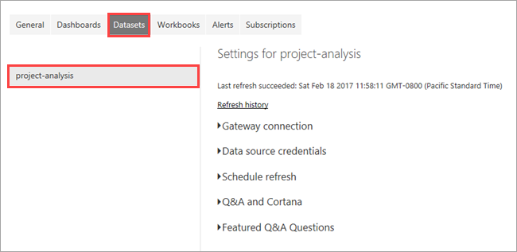

1. Expand **Data source credentials**, then click or tap **Edit credentials**.

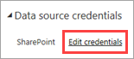

1. Select **OAuth2** for Authentication method, then click or tap **Sign in**.

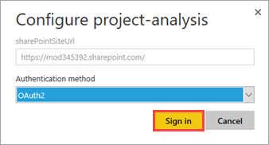

1. Select or sign in to an account that has permissions for the SharePoint lists.

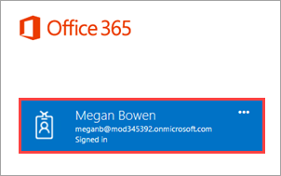

When the process completes, you'll get the following message in the service.

Data source updated.

## Step 3: Create a dashboard

1. To get back to your report, under **REPORTS** click or tap **project-analysis**.
2. Click or tap the chart on the upper left, then click or tap Pin icon..

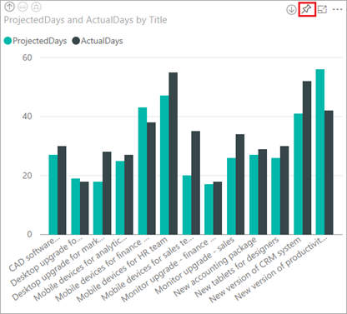

1. Enter a name for the dashboard you want to pin to, then click or tap **Pin**.

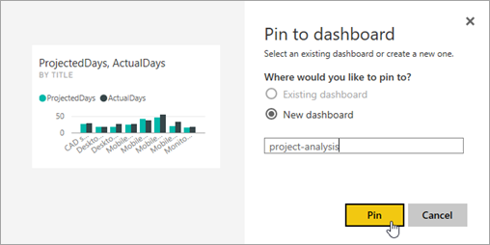

1. Click or tap the chart on the upper right, then click or tap tap Pin icon..

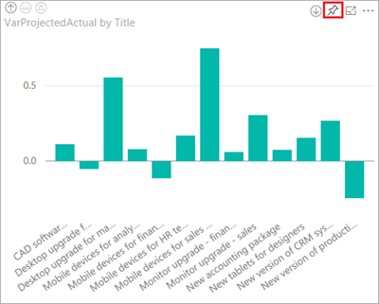

1. Select the existing dashboard, then click or tap **Pin**.

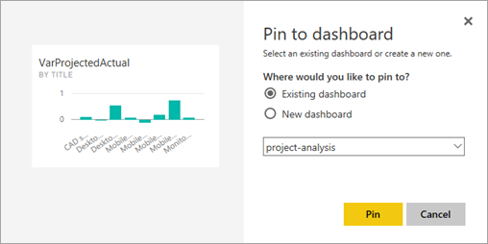

1. Repeat the pinning process for the other two visuals.
2. In the left navigation pane, click or tap the dashboard name.

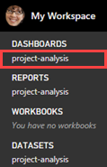

1. Review the dashboard. If you click on a tile, you will go back to the report.

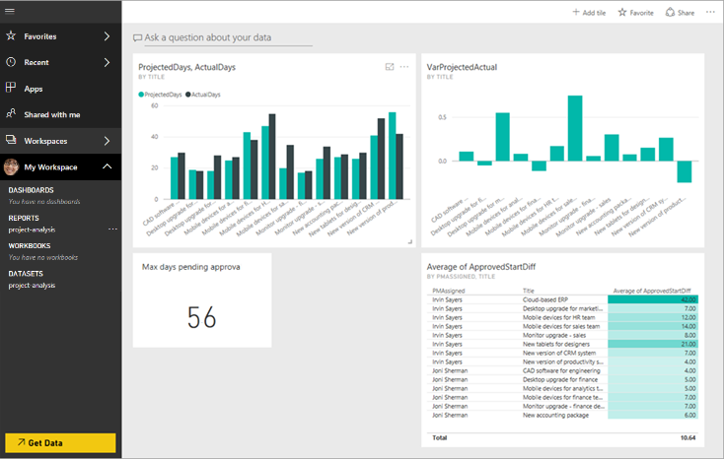

That wraps up most of the work in Power BI.